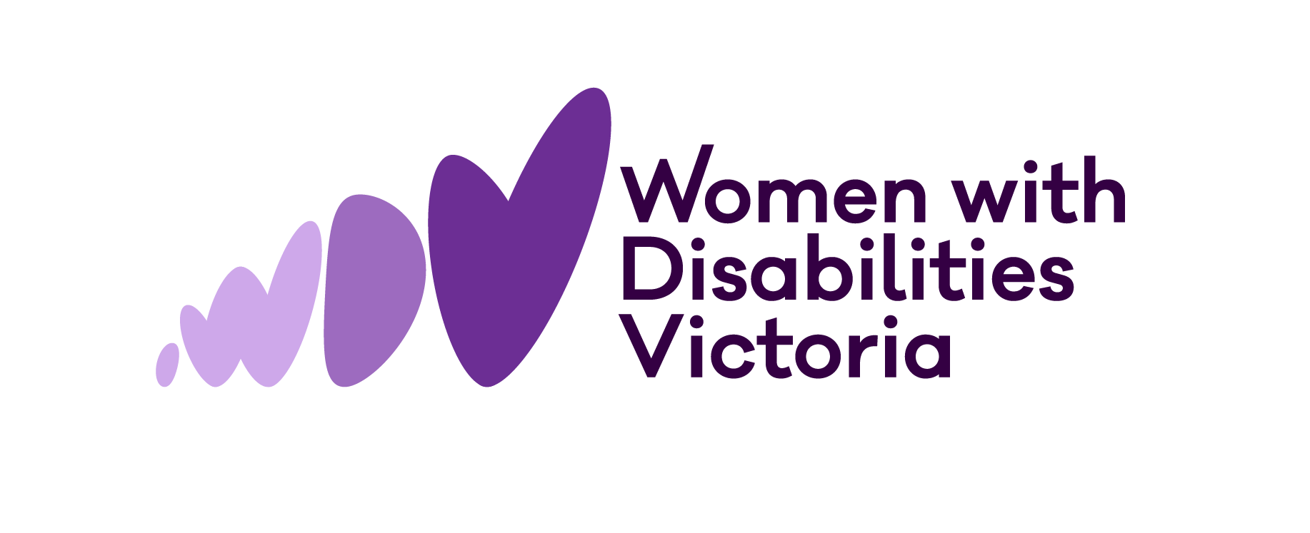

Understanding Disability (video transcript)

Every single Victorian woman is made up of many parts – how they look, who they love, what they do, how they choose to do it. Women with disabilities are no different, yet for decades they've been treated as if they are. They've been discriminated against, treated without respect, targeted for violence, and denied positions of responsibility and power. Throughout history, women with disabilities were treated as if they needed to be silenced or to be fixed in some way. Women have been treated like this by society. By community. By carers. By family.

Today we can and should think differently about disability. Women with Disabilities Victoria promote six keystones that make up how we understand disability and how we want others to understand disability.

The human rights model recognises that people with disabilities are entitled to the same rights as everyone else in society. Disability cannot be used as an excuse to discriminate or deny access or opportunity.

The social model of disability recognises that inequality does not result from impairment, but is created by a social environment that excludes people with disabilities from full participation in society due to attitudes and environmental barriers. Instead of focusing on what is wrong with a person, the social model focuses on what is wrong with the society we live in and what needs to change to achieve equitable opportunities and participation for people with disabilities.

The gender equality approach understands that there are important gender differences in how people with disabilities experience disability and how they are treated differently based on gender. The society we live in is not gender equal and this creates a unique experience of disadvantage for women and gender diverse people with disabilities.

An intersectional understanding of disability recognises that people's experience of disability is affected by intersecting social identities and experiences of discrimination and disadvantage, including race, class, nationality, sexuality, gender, religion, age, body shape or health status. The intersectionality model also recognises that within disability itself there are social hierarchies based on type of disability, how a disability was acquired or having invisible disability.

Centring of lived experience means bringing an awareness that people with a personal experience of disability are the experts of their own lives, their own bodies, their own minds, and their own needs. Not the family members, carers, doctors or other professionals. This model champions the idea that when people with disabilities are given information in an accessible way, when they are supported to understand the impacts of their options, and when they're given sufficient time to communicate and consider their options, then they are the person who is best placed to make decisions about what is best for them. This approach demands genuine consultation on all issues, policies and practices that affect the lives of people with disabilities.

Disability pride is a concept that promotes the inherent dignity and worth of people with disabilities. Having a disability is not a tragedy and not something to be ashamed of. Disability pride upholds the belonging of people with disabilities in society and celebrates our many contributions.

None of these models should be viewed in isolation. We must acknowledge all of
them for a more inclusive and equitable society. So, challenge your own unconscious bias. If you see ableist behaviour, call it out. Design structures, programs and practices that are accessible and approachable and promote respect, choice, autonomy and equal opportunity. Education is key, so ask the experts, and remember, that's the women with disabilities themselves.

You can watch the Understanding Disability video online.

