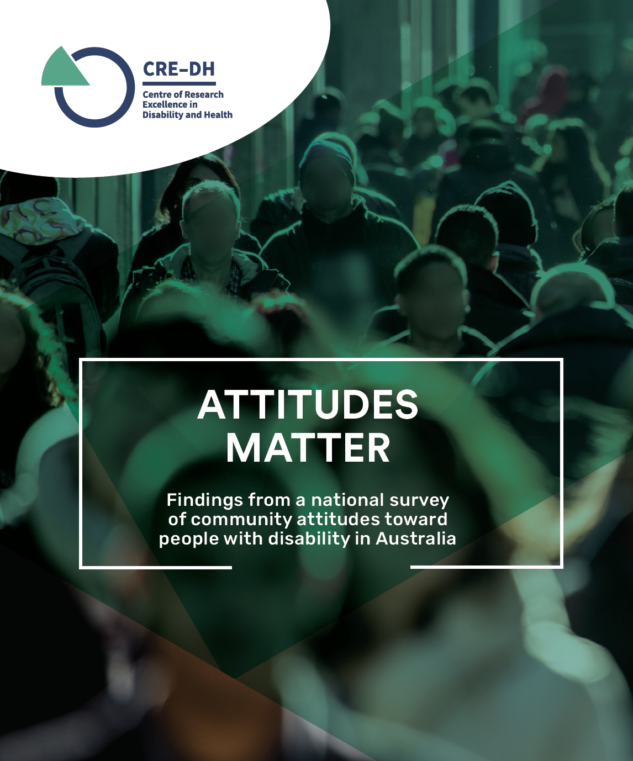



Research Report

Attitudes Matter – Findings from a national survey of attitudes towards people with disability in Australia.

Easy Read version

Centre of Research Excellence in Disability and Health

August 2021

How to use this report

The Centre of Research Excellence in Disability and Health (CRE-DH):
- did some research
- wrote a report about what we found
The report is called Attitudes Matter: findings from a national survey of community attitudes towards people with disability in Australia.
You can find the full report on our website.
We have written some words in bold.
This means the letters are thicker and darker.
We explain what these words mean.
There is a list of these words on page 14.
This is a summary of the full report.
A summary only includes the most important ideas.
Researchers from the University of Melbourne wrote this report.
When you see the word ‘we’, it means the researchers.

In this report, we talk about things that might upset some people.
You can ask for help to read this report. A friend, family member or support person may be able to help you.

What is in this report?
Page Number
What is this report about? 5
What did we learn from our research? 7
What we can do to make things better 12
Word list 14
Contact us 17

What is this report about?

This report is about our research.
Our research looks at attitudes toward people with disability in Australia.
Attitudes are what people:
- Think
- Feel
- Believe
Attitudes can affect
- What you do
- How you live your life
Attitudes can affect how people with disability are treated by:
- People
- Organisations
- Government
Attitudes can stop people with disability from being included.
This means that people with disability do not feel:
- accepted
- like they belong.

In 2018, we did a survey called Community Attitudes towards People with Disability in Australia.
A survey helps us to work out:
- What people are thinking
- What needs to change.
The survey asked:
- what people think about people with disability
- how people behave towards people with disability
- what they think other people think about people with disability
People with disability helped write the survey.
2000 people did the survey.
Attitudes have an important role in including people with disability.
When people with disability are included, everyone can take part.
We want to understand what people think about people with disability.
This is so they can be better included in everyday life.

What did we learn from our research?

This is a summary of what we found.
A summary includes the most important ideas.
The survey told us that most people in Australia have good attitudes towards people with disability. An example of a good attitude is that people with disability are very capable.
Capable is when you can do things well.
The survey told us that some people in Australia have bad attitudes towards disability in Australia. An example of a bad attitude is that people with disability are not expected to do very well.

Common beliefs
The survey tells us about some common beliefs people have about disability.
A common belief is when many people think or believe the same thing.
In the survey, some common beliefs are that people with disability:
- are not expected to do very well
- are easy to take advantage of
- have less to look forward to
- are a burden on their family or on the community

Burden means something difficult that you must deal with or worry about.

Another common belief is that many people feel inspired by people with disability.
Inspired means they look up to them.

Making decisions
The survey told us that some people believe that people with disability do not have the right to:
- make their own decisions
- have choice and control in their own lives.
This attitude can be a barrier. A barrier is something that stops you from doing something you:
- need to do
- want to do
Many people with disability experience barriers in their life such as:
- where they live and who they live with
- who they have relationships with
- their health
- their education
- their job.

Some people told us that they believe that people with disability should not:

- talk about sex

- have children.

This attitude is called paternalism.

Paternalism is when you think someone:
- needs to be protected
- can’t look after themselves.
Paternalism can also mean you treat someone like a child.

Many people told us that people with disability should get to decide:
- where they live
- who they live with
- who they have close relationships with.

Behaviour towards people with disability

Some people told us they are unsure how to act around people with disability.

Some people in the survey told us other people can be:

- impatient with people with disability
- make fun of people with disability
- ignore people with disability

- treat people with disability as if they have no feelings.

These attitudes and behaviours can lead to discrimination. Discrimination is when you treat someone badly because they are different.
Many people with disability face discrimination. Sometimes they face discrimination because of:
- their disability
- other things they cannot change.
The survey asked about inclusion.
Inclusion means everyone feels part of a group or part of the community. Everyone wants to feel included.
The survey asked about whether people think people with disability feel included:
- At work
- At school
- In friendships
- In the community

The survey told us that many people believe that:
- schools are not accepting of children with disability
- workplaces are not accepting of people with disability

Many people also told us that they think it is hard for people with disability:

- to make friends

- take part in the community
However, most people want to include people with disability.

An inclusive community:
- has supports and services for everyone to use
- lets everyone take part as equals
- lets people with disability take part in making decisions about the community.
In an inclusive community, people with disability:
- are respected
- get an equal chance to take part
- feel important
- can build good relationships and make friends
- get the support they need in the community.

What can we do to make things better?

The survey told us that most people in Australia have good attitudes towards people with disability.
There are also some people with bad attitudes towards people with disability.
It is important to change attitudes that make people with disability feel invisible, left out or isolated and alone.
We know that these attitudes can sometimes lead to violence and abuse.
People with disability have the right to live free from these things.
That is why we have a Royal Commission into Violence, Abuse, Neglect and Exploitation of people with disability.
A royal commission is how the government looks into a big problem. It helps us find out what:
- went wrong
- we can fix.
The Royal Commission is looking at ideas for making things better for people with disability including how to change bad attitudes.
Australia is trying to become more inclusive:
- In 2008, the Australian Government agreed to follow the UN Convention.
The UN Convention sets out the rights of people with disability.
It explains how people with disability should be treated.
We know that attitudes are very important in:
- Education
- Employment
- Justice system
- Health and wellbeing.
The survey tells us that government, organisations and companies must change their attitudes towards people with disability.
This means they must support the right of people with disability to be:
- independent
- fully included in our community.
When you are independent, you are in control of your own life and choices.
That means we must:
- do more to change attitudes to disability
- remove barriers for people with disability
- take action when people discriminate against people with disability
- think about inclusion and equality when creating policies and laws
- give people with disability a chance to be involved in the creation of new laws and policies.

Word list
This list explains what the bold words in this paper mean.
Attitudes
Attitudes are what people think, feel and believe.
Barrier
A barrier is something that stops you from doing something you need or want to do.
Burden
Burden is something difficult that you have to deal with or worry about.

Capable
Capable is when you can do things well.
Common belief
A common belief is when many people think or believe the same thing.
Discrimination
Discrimination is when someone is treated badly because of something about them they cannot change.
Employment
Employment means you have a job, go to work, get paid.
Inclusion
Inclusion means everyone is included and can take part in our community.

Inclusive
When something is inclusive, everyone can take part.
Independent
When you are independent, you are in control of your own life and choices.
Inspired
Inspired means people look up to someone or something.
Justice system
The criminal justice system deals with criminal offences. This is also called breaking the law.
Laws
Laws are rules about what you should and shouldn’t do.
Paternalism
Paternalism can mean you treat someone like a child, or when you think someone can’t look after themselves.
Policies
Policies are government plans for how to do things.
Respect
Respect is when people are treated equally.
Rights
Rights are rules about how everybody should be treated fairly.
Royal Commission
A royal commission is how the government looks into a big problem. It helps us find out what went wrong and what we can fix.
Summary
A summary includes the most important ideas.
Survey
A survey helps us to work out what people are thinking and what needs to change.
UN Convention
The UN Convention sets out the rights of people with disability. It explains how people with disability should be treated.
Violence
Violence is when someone hurts you physically.
Workplaces
Workplaces are any place you work, such as:
- an office
- a factory
- a shop.

Contact us
You can email us at:
cre-dh@unimelb.edu.au
You can call us at:
Tel. 03 8344 0717

For more information about us, you can visit our website:
https://www.credh.org.au

