Explaining the evidence for reform series

The logic for reform: employment for people with intellectual disability in Australia

  - Wilson, E., Qian-Khoo, J., Crosbie, J., & Campbell, P. (2022). The Logic for Reform: Employment for People with Intellectual Disability in Australia, Explaining the Evidence for Reform Series. Hawthorn: Centre for Social Impact. DOI: 10.25916/53n8-4a80
People with an intellectual disability want to work for the same reasons as other people; the social benefits of being with other people, to learn skills and get job satisfaction, and to earn a wage (Inclusion Australia and People with Disability Australia, 2022, p. 5).
People with disability can work if given the right support (AFDO, 2018, p. 15).
If people are willing to work, they should be supported to regardless of
assessed capacity (Down Syndrome Australia, in DSS, 2018, p. 37).

The goals
Goal 1: All people with disability who want to work should have the opportunity to work in all employment settings.
This goal substantially shifts the way employment settings have been conceived of for people with significant disability. It potentially has ramifications for the Disability Services Act, 1986, and also for the Disability Discrimination Act.
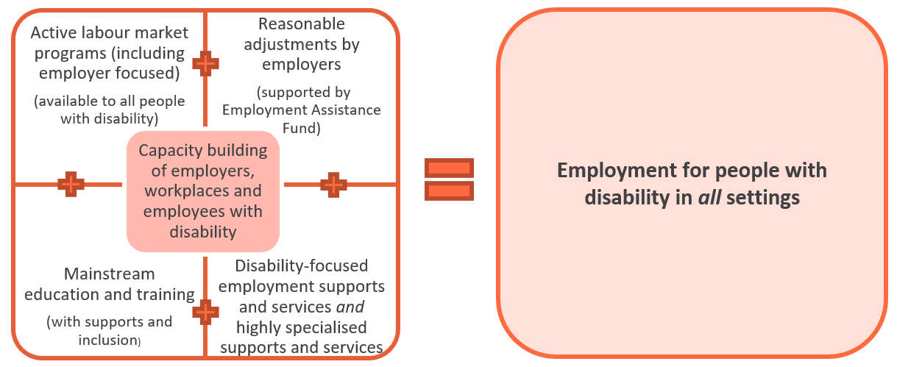

Dismantling segregating policy
Current Commonwealth government policy is based on a binary division, established by the Disability Services Act 1987, between those who can work ‘independently’ and therefore entitled to support to access ‘open employment’ (i.e. competitive, integrated employment), and those that are assumed to be unable to work in open or competitive environments and therefore expected to work in ‘supported employment’ settings (ADEs).
Commonwealth government active labour market policy and programs have similarly offered employment supports linked to concepts of work capacity. This has resulted in a form of structural segregation where work capacity classifications unlock different levels and types of employment supports, leading some to be locked out of supports. Employment supports have largely been premised on bifurcated thinking: customised and ongoing supports are only offered to those relegated to ‘supported employment’ provided only in specialised settings (ADEs), while job vacancy matching and limited support are offered to those deemed capable of open employment. In the main, this approach has locked people with intellectual disability into ADEs.
Dismantling the existing models:
Currently | → | Required
Division between Open and Supported Employment i.e. only offer high level of ongoing support in Supported Employment settings | → | The provision of support (including high levels of ongoing support) to be offered in ANY employment setting.
Match to existing job vacancy as primary logic of employment services. Job customisation is not provided by ALMP providers including DES. | → | Job customisation is a core employment support widely available for use in all employment settings. Job ‘creation’ and identification is a core strategy alongside job vacancy matching offered by a range of employment service providers.
DES is only for people who are not already employed | → | DES is widely available for all people with disability seeking employment support to access employment, including people moving from employment in ADEs to other forms of employment. DES offers a wider range of employment supports.
Notion of ‘independent’ worker is a pre-requisite for open employment (and related employment support) | → | Remove notion of ‘independence’ as a worker, i.e. a worker does not need to be independent of supports to successfully gain and maintain employment in any setting. Instead, entitlement to supports, adjustments and environmental modifications are routinely recognised and there is access to funded supports ‘beyond reasonable adjustment’ in all employment settings.
Employment services focused on narrow band of employment support interventions | → | Wide focus of employment services aligned to addressing biopsychosocial barriers to employment targeting the jobseeker, employer and workplace, and broader social and systemic contexts.
‘Supported wages’ that lock people into subminimum wage levels | → | If retained, ‘Supported wages’ explicitly require evidence of supports and adjustments that function to maximise productivity and employment opportunities

The frame for this policy shift is a commitment to the equal entitlement to employment in all settings for people with intellectual disability. Underpinning this is a dismantling of concepts of ‘open’ and ‘supported employment’, replacing these with a standard of high quality, inclusive employment that applies to all settings.
High quality, inclusive employment should be available in all settings and is characterised by:
- work that holds value for the employee with disability
- relevant and adequate supports being provided, including funding for higher levels of job customisations and ongoing support (‘supported employment’)
- integrated workforces (of people with and without disability) and/or
- integrated work settings (where work is community-facing or located in non-disability specific settings and industry workplaces), and/or
- highly effective pathways to integrated or hybrid employment
- adequate remuneration.

Goal 2: People with disability receive an appropriate range and level of employment supports to enable them to perform at their best in a workplace that fully supports them to do so.
To achieve the first goal of employment in all settings, people with disability and employers need access to an appropriate range and level of employment supports.
This substantially shifts the way work capacity is understood where capacity is linked to the provision of appropriate supports and the removal/remediation of barriers to employment. In this context the focus shifts from work capacity to strategies and support for capacity building (of both the employer/workplace and the jobseeker/employee with disability). Suitable employment is dependent on:
- reasonable adjustments being made by the employer (with the support of the Commonwealth government, for example via the Employment Assistance Fund or other mechanisms like tax rebates);
- the provision of other employment supports (targeting the jobseeker and/or employer). Employment supports should be both universal and specialist supports, with entitlements to both;
- the provision of additional highly specialised supports where ‘beyond reasonable’ adjustments and supports are required, such as high levels of job customisation, adaptations and on-going support (to both employer/workplace and employee).
A non-segregated employment support system: equal access to all employment services
The type and availability of employment supports should not be limited by the type of income support payment a person is entitled to nor the assessment of ‘productivity’ or ‘work capacity’. All citizens should have the same right to access employment supports funded by Government. Assessments of additional barriers or need should unlock additional supports, not relegate individuals to a more limited form of employment supports and employment options. (See Paper 1). Access to upgraded or specialised services should be available in addition to, work in collaboration with, and not replace the right of entitlement to, ‘mainstream’ or universal employment supports and services.

Employment supports and services that directly address the full range of (biopsychosocial) barriers to employment
Employment supports and services need to be designed to be appropriate to the needs of jobseekers with intellectual disability. This includes a re-design of existing active labour market programs to ensure they include all people with disability and supply relevant employment supports. Effective employment supports are those that address the barriers to employment for each individual across a wide range of focuses. Jobseekers with disability need to be able to select from the whole range of inclusive mainstream employment services and a specialised set of employment services, not be streamed into one or another. (See Paper 2).
Evidence based and effective employment supports for people with intellectual disability
There is international and domestic evidence about the design and delivery of effective employment supports and services for people with intellectual disability. These supports need substantial investment to upscale their availability in Australia to all people with intellectual disability and their employers regardless of their location. (See Papers 2 and 3).
Re-focusing the contribution of ADEs
The role and activities of ADEs can be re-imagined. ADEs can offer:
- the creation of jobs that are designed to build and maximise the capacity of employees with moderate to significant disability, and of other groups;
- opportunities to trial/gain work experience in a range of industries and work settings including among integrated workforces and/or settings; and
- clear pathways to other employment opportunities beyond the enterprise.
In addition, there is a need to build the market of specialist employment service providers who have the expertise to provide employment supports in workplaces where ‘beyond reasonable adjustments’ are required. This typically requires high levels of job customisation and the provision of on-going employment support delivered to meet the needs of all employment settings (See Papers 4 and 5). This may be an additional area of commercial operation for some ADEs if they can be supported to re-work their business models to unlock their specialist expertise (and workforce) for use as employment specialists to support other workplaces.
The funding of employment supports
Sufficient funding needs to be available to fund the full range of employment supports, for both jobseeker/employee and employer/workplace, as well as the wider societal supports around these (such as regional school leaver or employment networks). The NDIS has disrupted the exclusive funding of ‘supported employment’ to ADEs, enabling employment-related funding to be used in any employment setting. NDIS funding is now potentially a mechanism to ensure that all levels of job customisation, workplace adjustments and ongoing support (beyond those reasonably required by the Disability Discrimination Act) can be provided across all employment types. However, this funding has not been designed to cover a wide range of employment supports or ongoing capacity building needed to enable people with significant disability to perform at their best in a workplace that fully supports them to do so. Nor does it address the requirements of employers and workplaces for the level of capacity building required. Additionally, the market of suitable providers of the wide range of employment supports is inadequate (or non-existent) and needs explicit investment and curation. Similarly, a mechanism to join-up or supplement employment supports and services in a wide range of systems and jurisdictions is required that addresses how to utilise individualised funding in inter-linked systems.

Explaining the evidence for reform series
The Centre for Social Impact (CSI) has undertaken a range of research related to the employment needs of people with disability over several years, in addition to a substantial body of research related to social enterprise. The Explaining the Evidence for Reform Series draws on this research and synthesises its evidence. In addition, CSI researchers undertook a rapid review of evidence relating to the Australian Disability Enterprises (ADE) sector drawing on published studies, policies, and reports; the publicly available aspects of the Buyability data set (managed by the National Disability Services); and a desktop review of ADEs.
Together, this research base was organised to present evidence in five papers, with this ‘Logic for Reform’ paper as an overview of the underpinning logic emerging from the research. The series includes:
Paper 1: Understanding the Employment Ecosystem for People with Intellectual Disability.
This paper provides an overview of the employment ecosystem which constructs access to employment supports for people with disability.
Paper 2: Understanding the elements of employment support.
This paper explains the range of employment supports that should be available, and the extent to which they are provided in the current system.
Paper 3: School Leaver Employment Support (SLES) – Reshaping the Approach.
This paper collates the existing data available on SLES, and on the experiences of young people with intellectual disability seeking school to work transition. It identifies employment support needs aligned to best practice evidence.
Paper 4: The ADE Snapshot.
This paper collates the existing data available about ADEs, adding new data to identify the current state of the ADE sector.
Paper 5: The WISE-Ability Model.
This paper presents a new model for ADEs: the WISE-Ability model. The model articulates the organisational elements that build capacity of employees including pathways to open employment. The paper also identifies data from research about the funding barriers to transitioning employees from ADEs to open employment.

References
Australian Federation of Disability Organisations (AFDO). (2018). Paper: The future of supported employment in Australia. AFDO. https://engage.dss.gov.au/wp-content/uploads/2018/03/AFDO-Future-of-Supported-Employment-Paper-2018-03-FINAL.pdf
Department of Social Services (DSS). (2018). Ensuring a strong future for supported employment. Consultations, summary of stakeholder consultations December 2017-April 2018. https://engage.dss.gov.au/wp-content/uploads/2018/07/PROOF-7-8876-Supported-Employment-Policy-Report-FINAL.pdf
Inclusion Australia and People with Disability Australia. (2022). Wage equity and more choices in employment for people with intellectual disability. Research review. https://pwd.org.au/wp-content/uploads/2022/04/ADE-research-brief-April-2022.pdf

