Open employment and people with intellectual and developmental disabilities
  - An easy-read research summary

Dr June Alexander and Dr Angela Rong Yang Zhang
August 2026

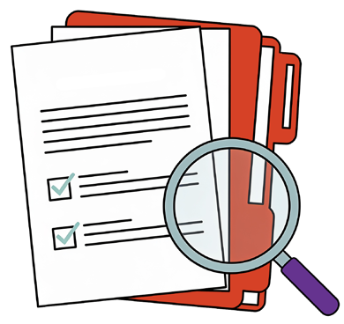
We did a Review on open employment research for people intellectual and developmental disabilities.
Easy Read

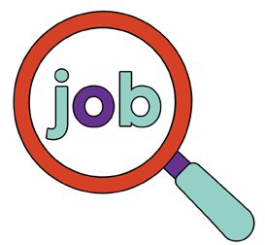
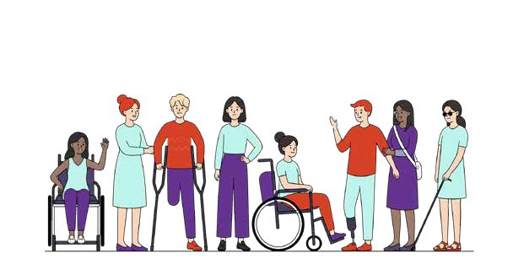
People with disabilities sometimes experience problems finding and keeping a job.

Some of the problems experienced are:


“I had to try find work myself.”

“My school had no training in job support.”

“They told me I can’t work in a normal job.”

“I got no help in the job.”

“There was no-one to ask when I got stuck.”

“Nobody at work talked to me much.”

“My job ended and I don’t know why.”

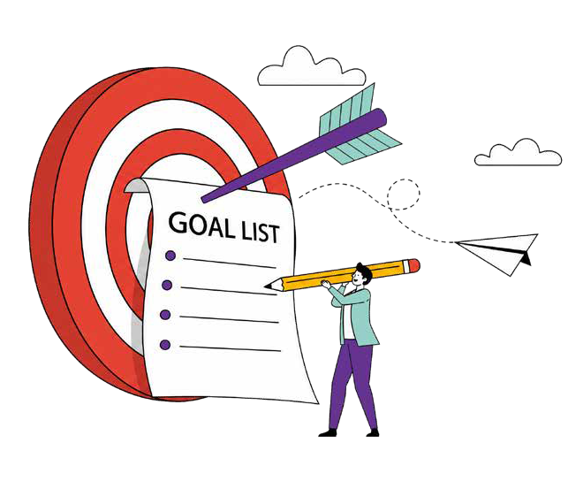

Employment for people with disability can be better by making some changes.

Changes are needed in:

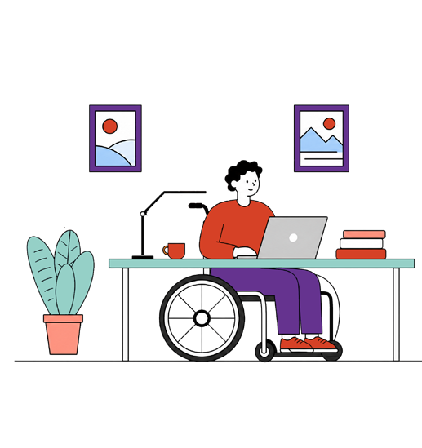
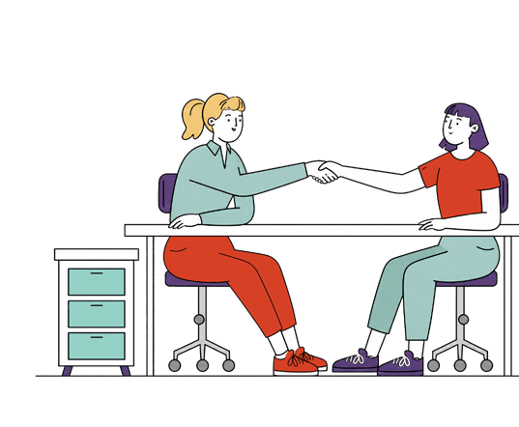

- Employment Supports

- Workplaces

The Review talked about:
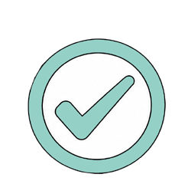




What works

What does not work

And how to use the results

What works:

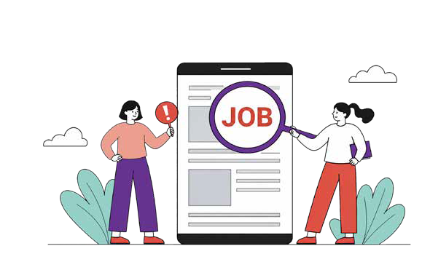
- Help finding a job

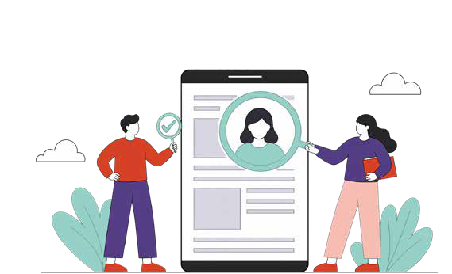

- Start with the person, then shape the job

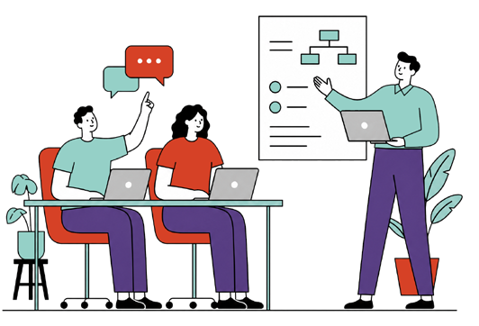

- On-the-job training

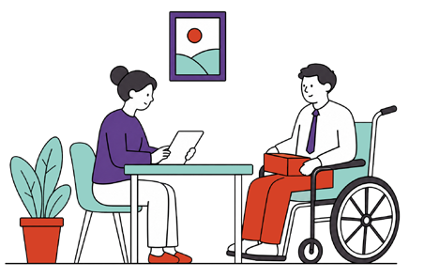

- Ongoing job support

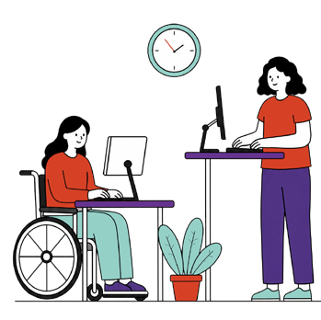

- Inclusive work environments

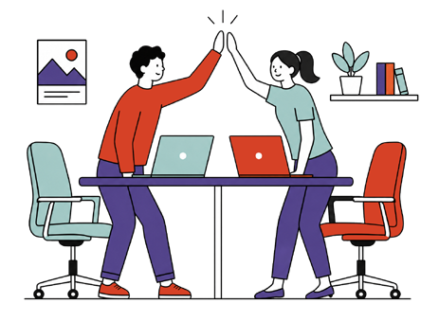

- Positive working relationships

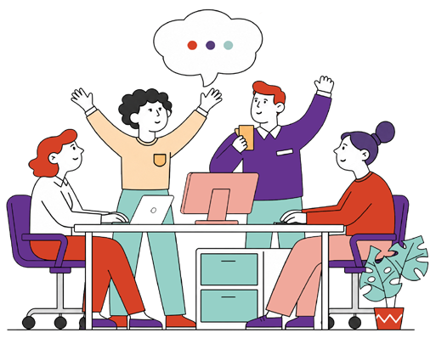
An inclusive work environment helps you keep your job.

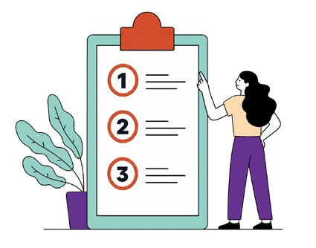
Good work environments have:

- Clear instructions

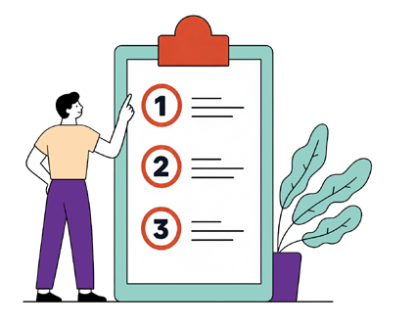



- Clear expectations

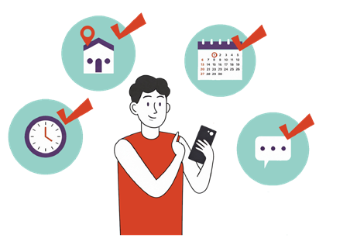

- Regular routines

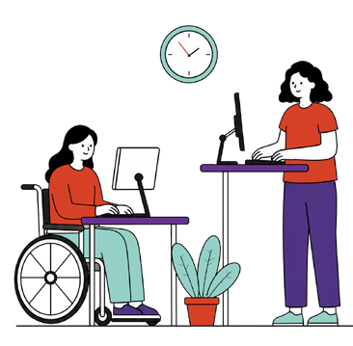
- Inclusive workspaces

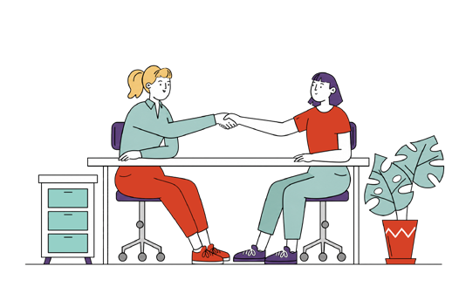
- Support when needed

“People do best when they get all the help they need.”

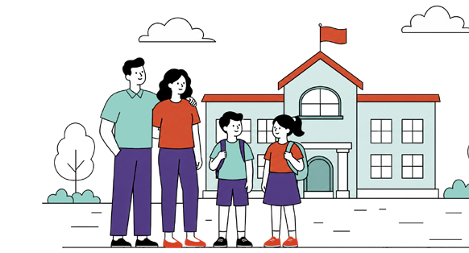
Planning for work should start with families and schools.

“Early work experience is a great helping hand.”

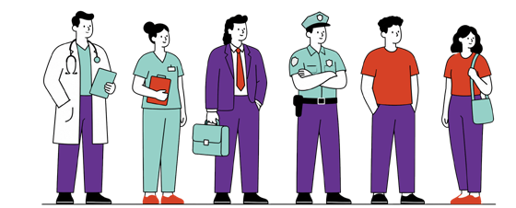

What does not work:

Things work best when families, schools, employment services, employers and disability providers work together.

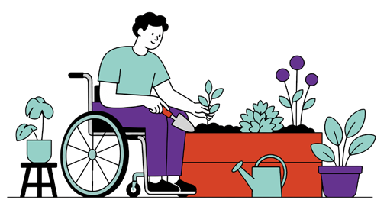


- Work experience with no plan for a job

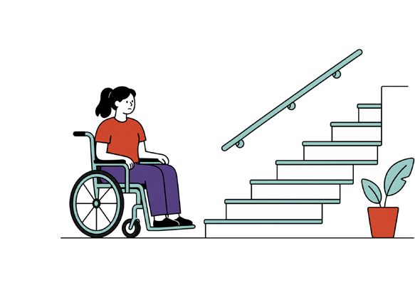
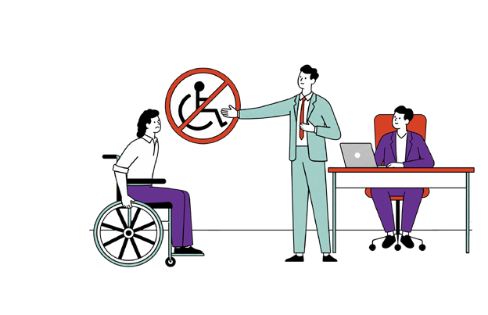

- Little or no understanding of disabilities

- Little or no understanding of the person with disability

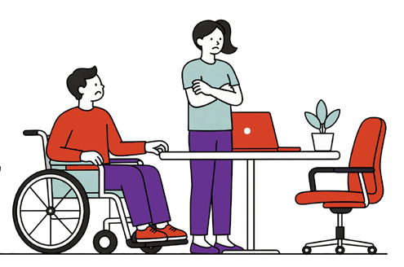
- Not enough support on the job.

Changes should involve the following people:

- Employment services and job coaches
- Employers
- Families
- Schools
- NDIS funded disability supports

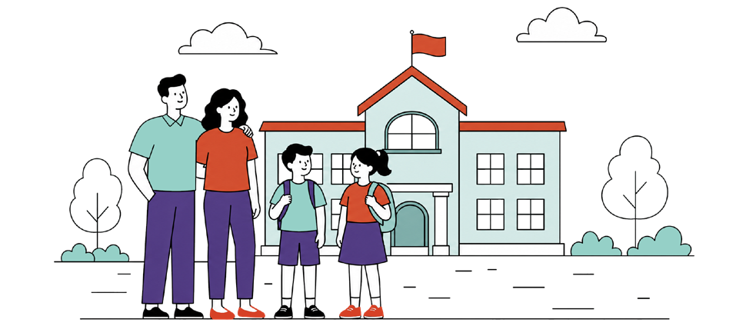

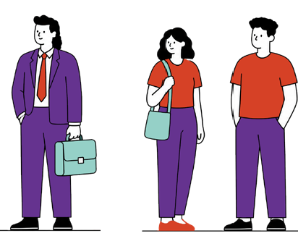

What these people should do:

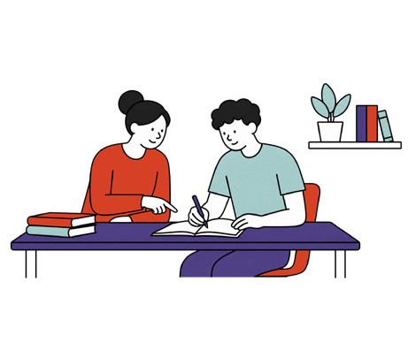

  - Start to plan early before students leave school


  - Work at building strong relationships with everyone involved

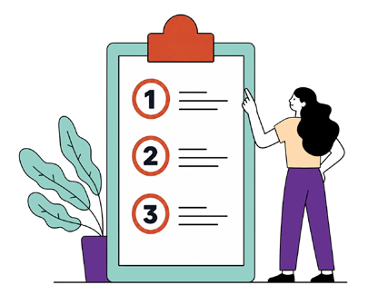

  - Design jobs to be clear and easy to understand

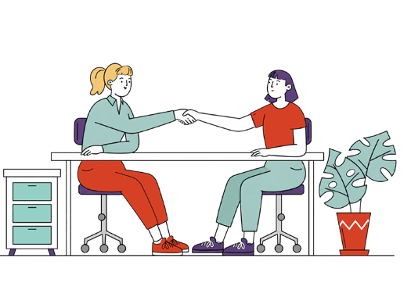

  - Provide regular and ongoing support

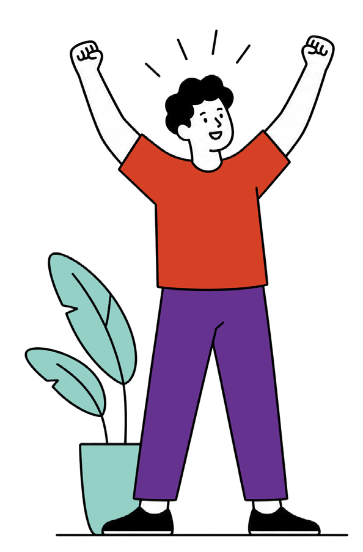
What people with disability should do:

  - Think Big

  - Stay positive Do your best.

Hard words

Open employment
= jobs in regular workplaces.

Inclusive
= making sure everyone is able to take part and is valued.

This easy read document was prepared by:

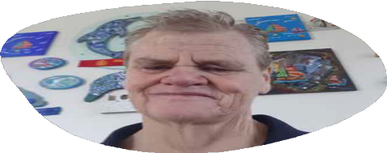

Mary



Kane

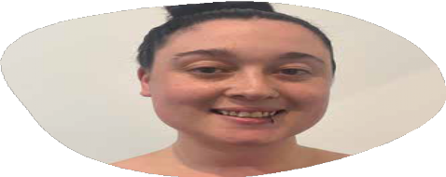

Amilia

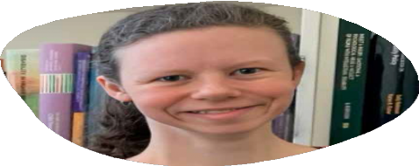

Ruby

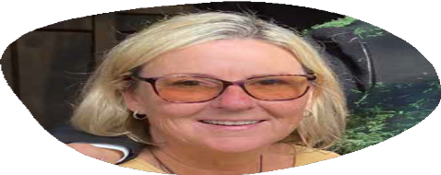

Collette

